I have included everything I have been able to generate so far regarding my data. I thought I would write this up a bit so that you can see where I am at, what I have done and what needs adding/completing.

I started by analysing the high dataset (with only high this time!) the figures and analyses below are from the high shock animals. Ignore the * in the figures. I have not figured out how to include significance stars (where the results were significant) in the complex bar charts yet.

**Pre-Post shock**

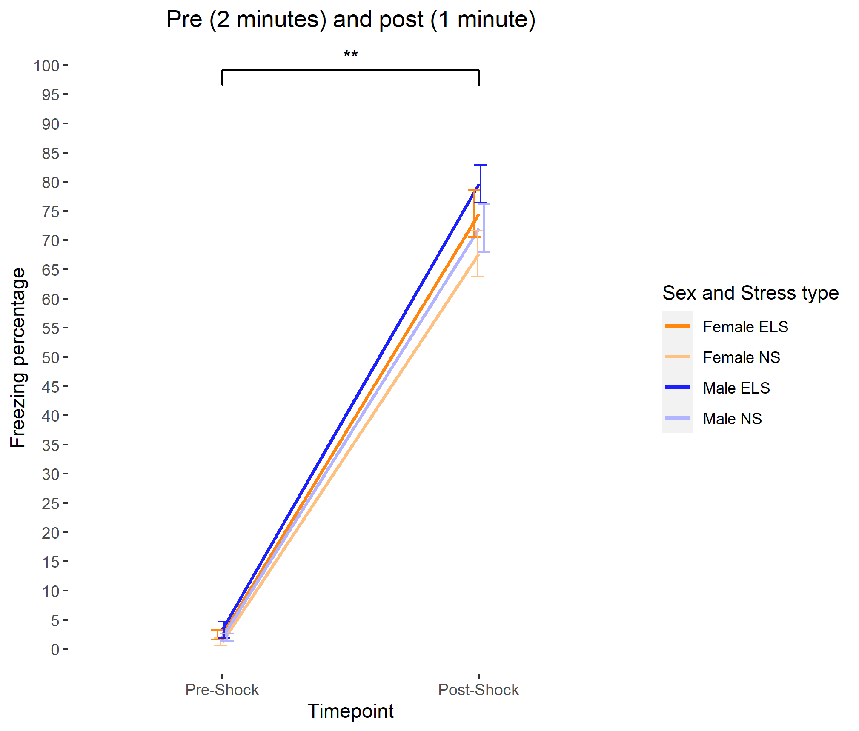

Here I think the tests and the results are fairly straight forward. ANOVA finds a significant effect of time point. Looking at the distributions it is fairly clear that neither of these are normally distributed. The skew shifts massively from right skew to left. Throughout the analysis this is a fairly common theme (highly right skewed). If I move past this, analysing with ANOVA finds a significant effect of time point (p<0001) and a significant effect of stress (p=0.035). I have conducted this by collapsing the pre and post labels into a single variable and adding that as a variable into my stats. I was also wondering if I would need to test for differences in sex and stress looking at only the post shock time point (or post shock with pre-shock as a covariate) Below shows the raw analysis.

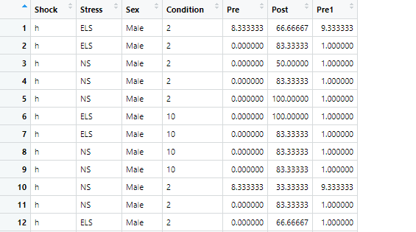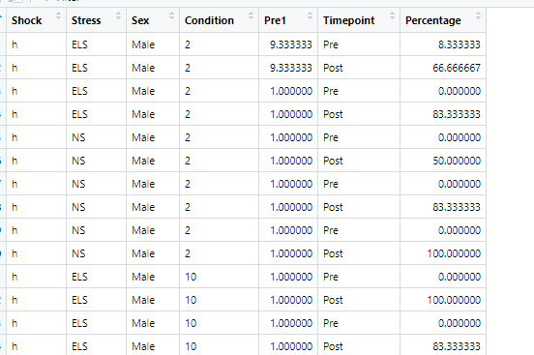

Pre1 was adding 1 to the values to try a transformation and is not used in this current analysis. Columns Pre and Post are combined to make the time point column.

The linear model used for this analysis is:

Using a linear model gives an adjusted R squared of 0.82. Time point is quite obviously explaining most of the difference seen here. Interestingly stress seems to show a significant main effect here with ELS freezing more than non-stressed (*post hoc needed here).

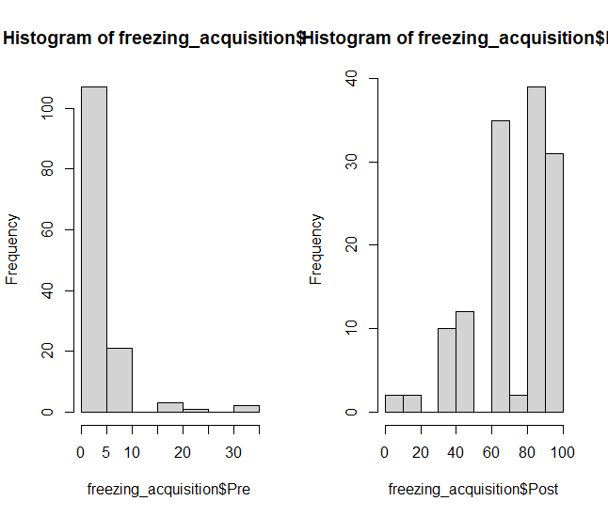

Running Shapiro on either of these DVs comes up highly significant. But from inspection of the histograms this appears obvious. Here, the results may be so non-normal that it would be impossible to transform. The values in the pre “condition” are likely at floor level with the converse for the post.

**Recall 1 – 48 hours following shock**

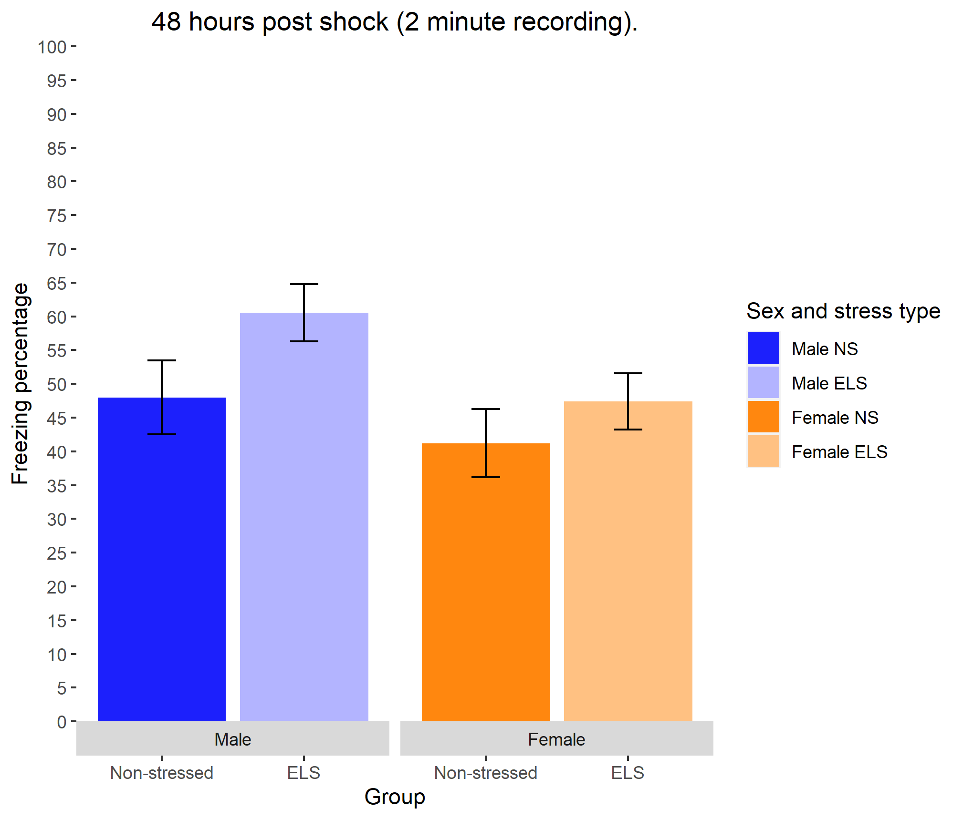

I set a linear model to look at the effects of Sex and stress and an interaction as follows:

Removing the non-significant interaction effect from the model (I am still unsure if I can do this, post analysis?) giving the following equation:

Has very little effect on the values and does not change the significance at all. The results here seem quite robust. I have seen this from the beginning and across multiple experiments and (potentially) across different shock groups (just with lower values).

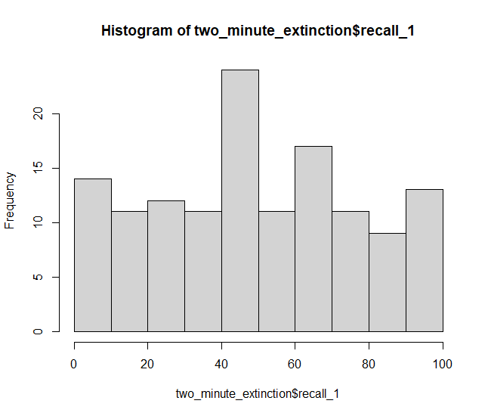Looking at the distribution here the values look fairly normal. Shapiro is still significant. However, it is 0.001247 (as opposed to > e-16 or so).

**10 minute extinction session**

**IVS- Sex Stress Time point**

**DV - percentage freezing at each timepoint(percentage 1-5)**

Here I begin to struggle to figure out the correct stats to understand everything, to pull out the right information from all of the data at 5 time points.

A few attempts consist of:

Model 1

Collapsing the 5 extinction points into one variable called time point, comparing the two main IVs and an interaction between them and then running the following linear model:

Model 2

Same as above but comparing Sex and Stress with time point as an interaction.

Model 3

Repeated measures – This seems the most logical way to do this as indeed the recording here is a repeated recording.

I had originally thought another model would be to do comparisons of the between subjects variables on each time point, but seeing as they are all highly related (being repeated measures) I discarded this model.

Checking the data before running through the model:

Histograms show fairly normal data for the first two extinction time points. Following this the skew goes strongly right. Shapiro shows a similar pattern with ext time point 1 normal. 2 significant p-value = 0.004726 and values after that increasing strongly in significance. Here I begin to see where tests which assume normality might be insufficient to detect differences. They might be strongly affected by the sheer number of 0 values which start to occur from time point 3. Very much expected, but something to consider.

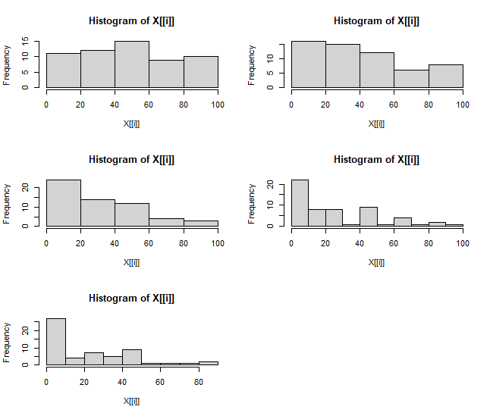

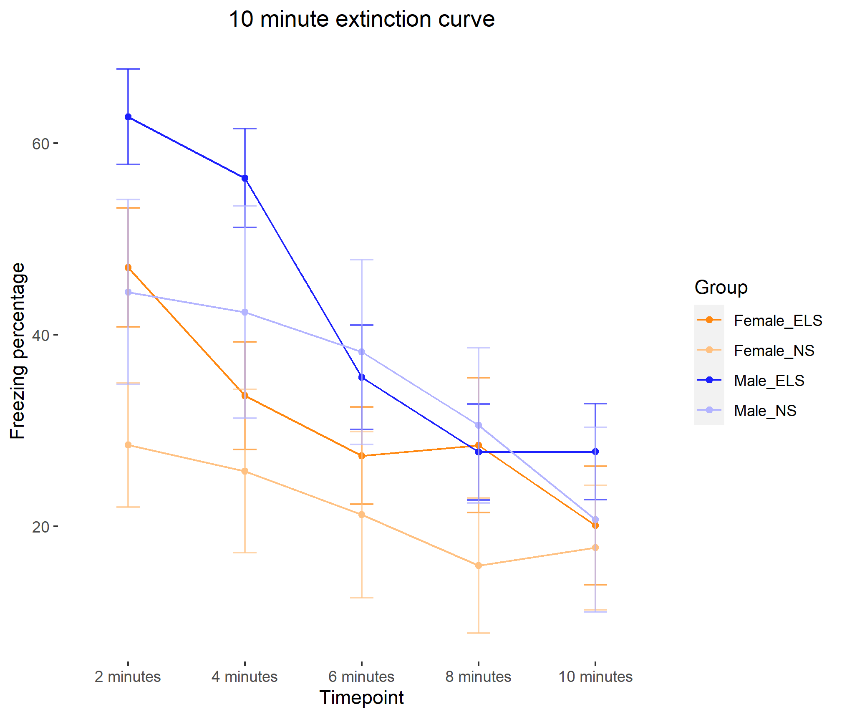

Model 1:

Collapsing the data from five columns to 1 to generate long dataset. 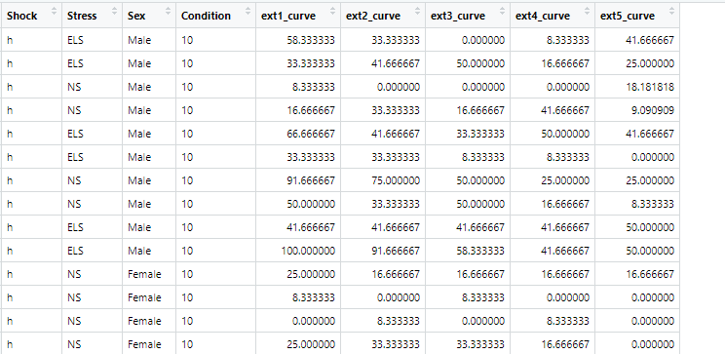

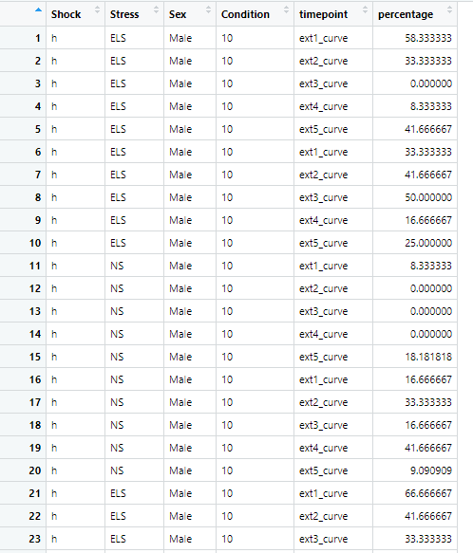

A fitted linear model shows highly significant stress and sex main effects. There is no interaction and there is a significant time point effect. I am not completely sure what this is showing, but I think I could conclude that the main effect is males freeze more than females across the whole line while stressed freeze more than females. These main effects tell us nothing however about where the difference in M/F or ELS/NS is apparent. For example looking at the lines there is a difference between male ELS and others at 2 minutes which may be detected. But then this effect is far less apparent at 6 or 8 minutes. I would conclude using one of the other models which is more specific for looking at M/F and ELS/NS effects at timepoint1, at time point 2… time point 5. I am conscious here that this would be multiple testing and I will have to figure out how to best account for that. Checking the ANOVA shows similar results but masks the interesting finding that freezing seems to not significantly drop (compared to time point 1, the intercept in this case, I think) until time point 3.

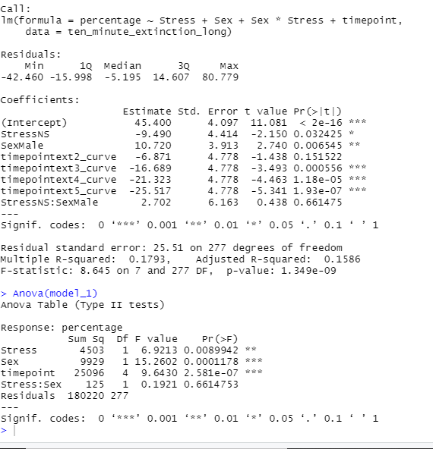

Model 2:

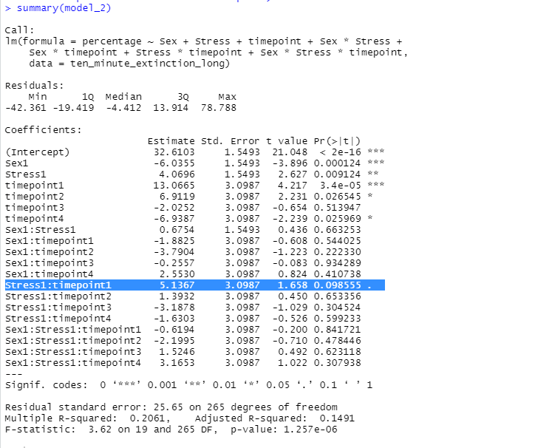

Model 2 seems to suggest no significant interaction effects. There are significant main effects of both sex and stress. But, I think this is looking at the difference between the two across all time points and it is obvious that there are differences if you collapse across time point. Not really sure how relevant this is though. I would suggest here (my understanding of the statistics is) that the main result is that the extinction worked but no differences between sex or stress on the extinction rate.

Model 3:

I am not able to run the repeated model confidently in R yet (I am sure there is a way) so I ran the model in SPSS. I have included the output as an attachment in the email I will have sent to you. Seems that there is an effect of time point (highly expected, showing across the groups the animals extinguished). No interactions or main effects significant. Stress and Sex are approaching significance in the linear contrast tests. But I am not sure this is relevant with a non significant overall anova model. This seems to be the model that makes most statistical and theoretical sense.

**Extinction recall – 48 hours following extinction procedure.**

Here I have thought that the main objective is to compare 2 and 10 minute animals in each group. Therefore, there are 4 analyses to do. Analyses are t-tests which are conducted where each green bar is. We discussed previously using ANOVA as a general overview. But I struggle to see how that would work here. Will ANOVA not look at the difference between ELS MALE 2 and NS FEMALE 10 for example (red line) and find this to be significant? So far I have run the t-tests as I suggest above (the green lines).

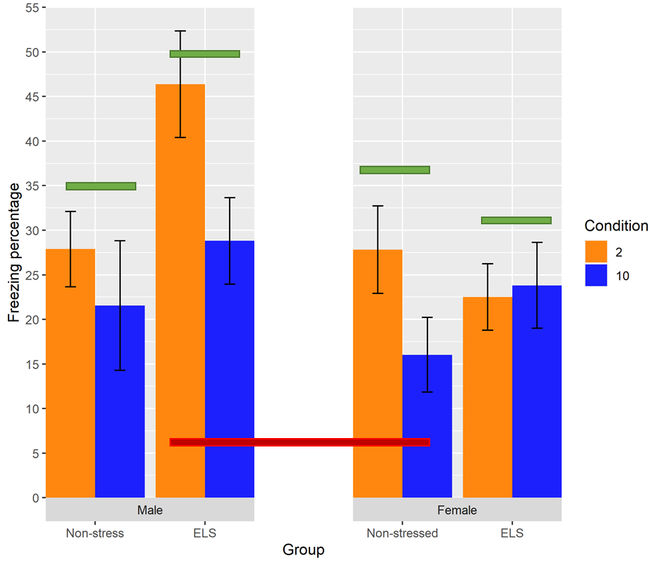

I have looked at histograms for all of the data in this figure.

R outputs weird titles right now. Each column represents 2 or 10 minutes. Row 1 to 4 is   
M ELS   
M NS   
F ELS   
F NS

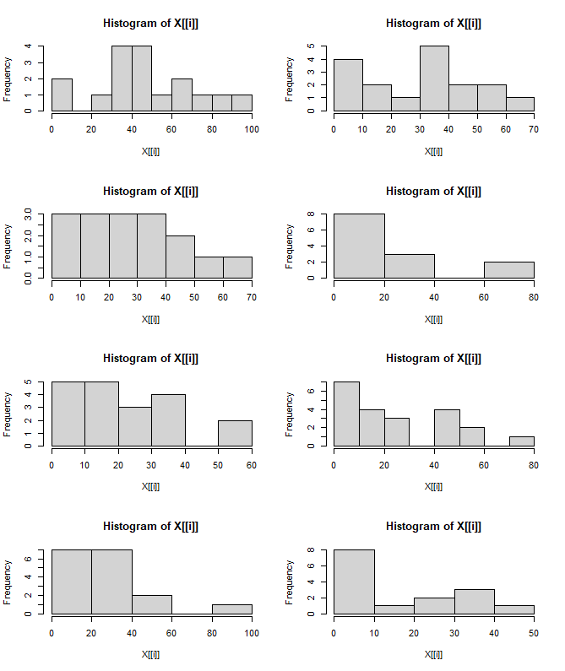

T tests on non adjusted data are as follows

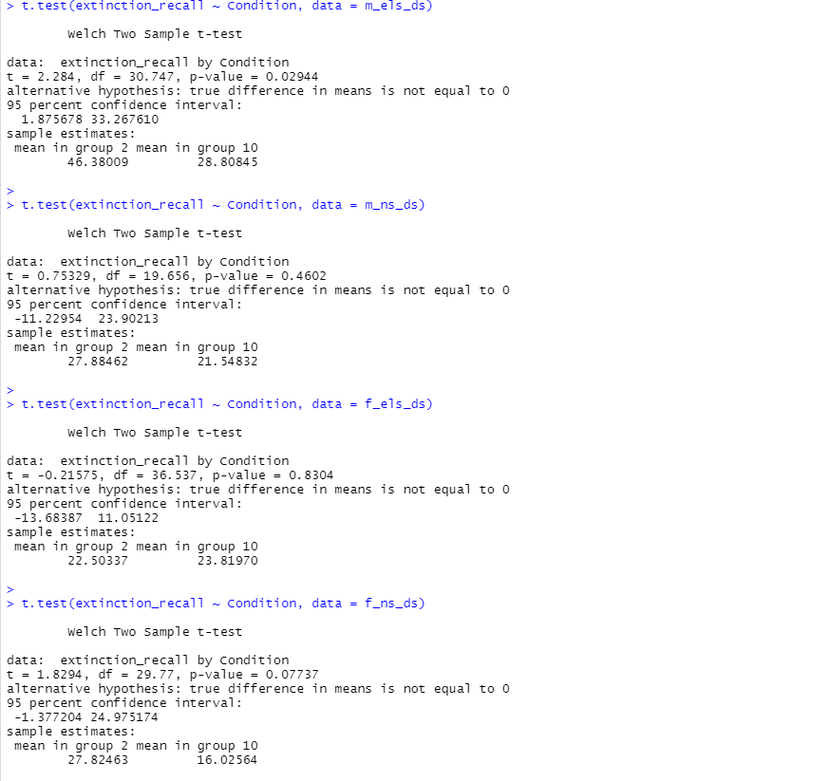

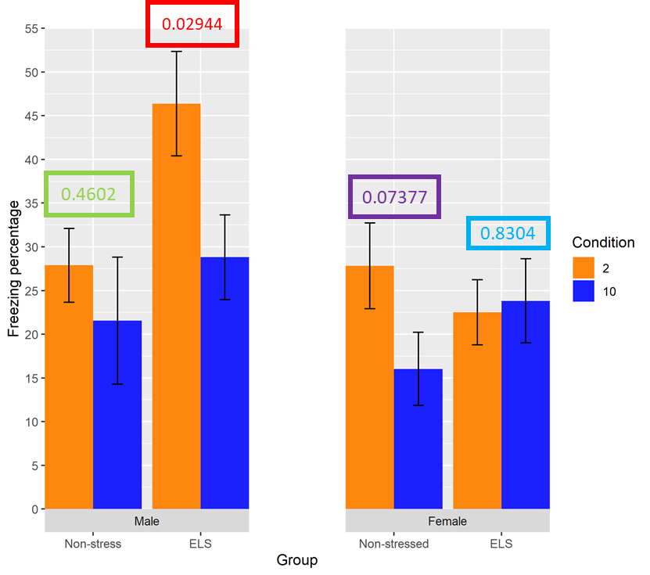

The value in purple is the value that is now not significant (compared to when I had included some of the values that were in the low shock group. Looking at the histograms suggest that the female non stressed group contains a lot of 0 values which skew the data strongly to the right. Perhaps if the 0 values were accounted for then a significant difference may occur. I am conscious of “massaging” my data to get a significant result here though. If I have a good reason for controlling for the 0 values which I have suggested above I don’t think this should be too much of an issue? This time point is the one which has me question the use of parametric models to test for differences the most.

Reminder and reminder recall

Here there is a lot of data to present. I recall from previously you often say you would want to see the extinction recall data in order to make a judgement on the reminder shock data and the reminder recall data. Perhaps there is a better way to show this.

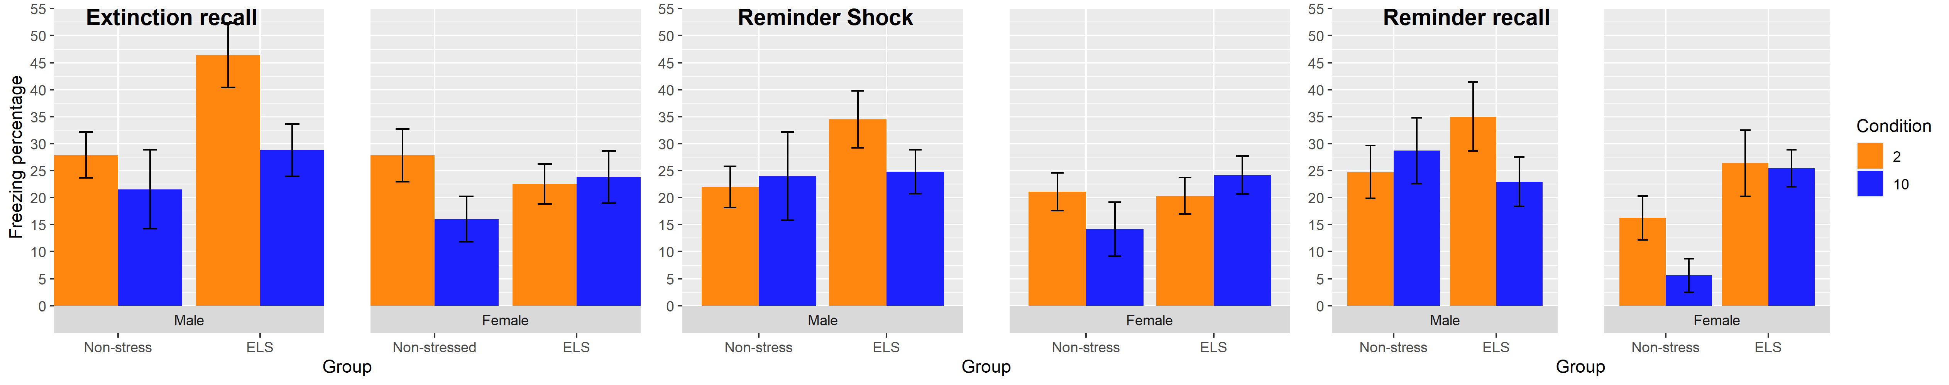

I am somewhat at a loss to how to analyse this data.

The analysis is still similar to the previous set of results (the extinction recall alone) however now we are looking to do each analysis with the previous set of data as a covariate.

Low shock results

The above issues relate to mostly all of the figures below. Most of this is just repetition with different values. I will only include data/methods that are new (for example I wont include how I have combined the variables to make a long dataset etc).

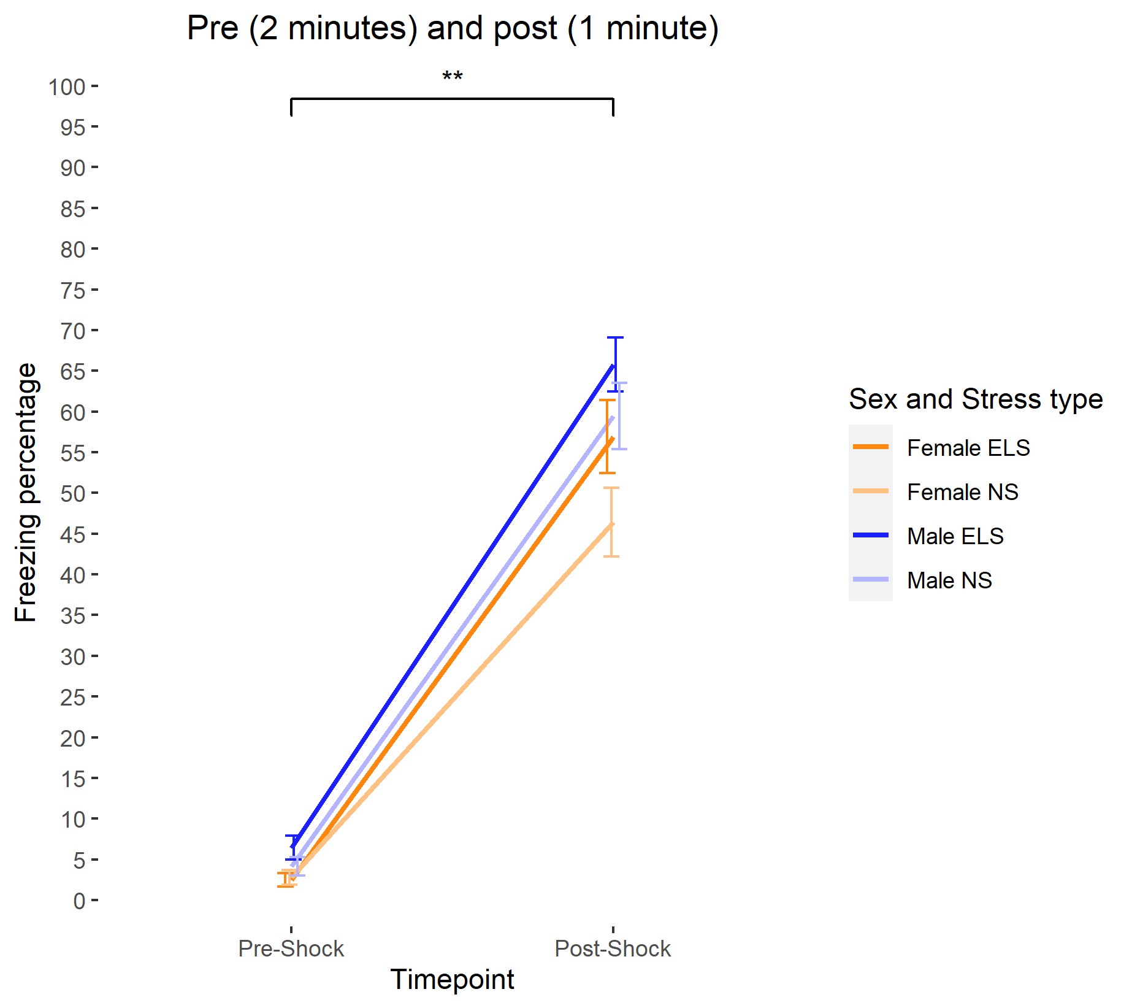

Here there is a main effect of sex and stress and timepoint. The results are similar to what was shown in the high group, just with lower results across the whole thing.

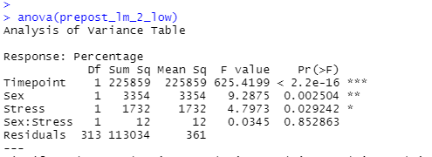

**Recall 1 – 48 hours following shock**

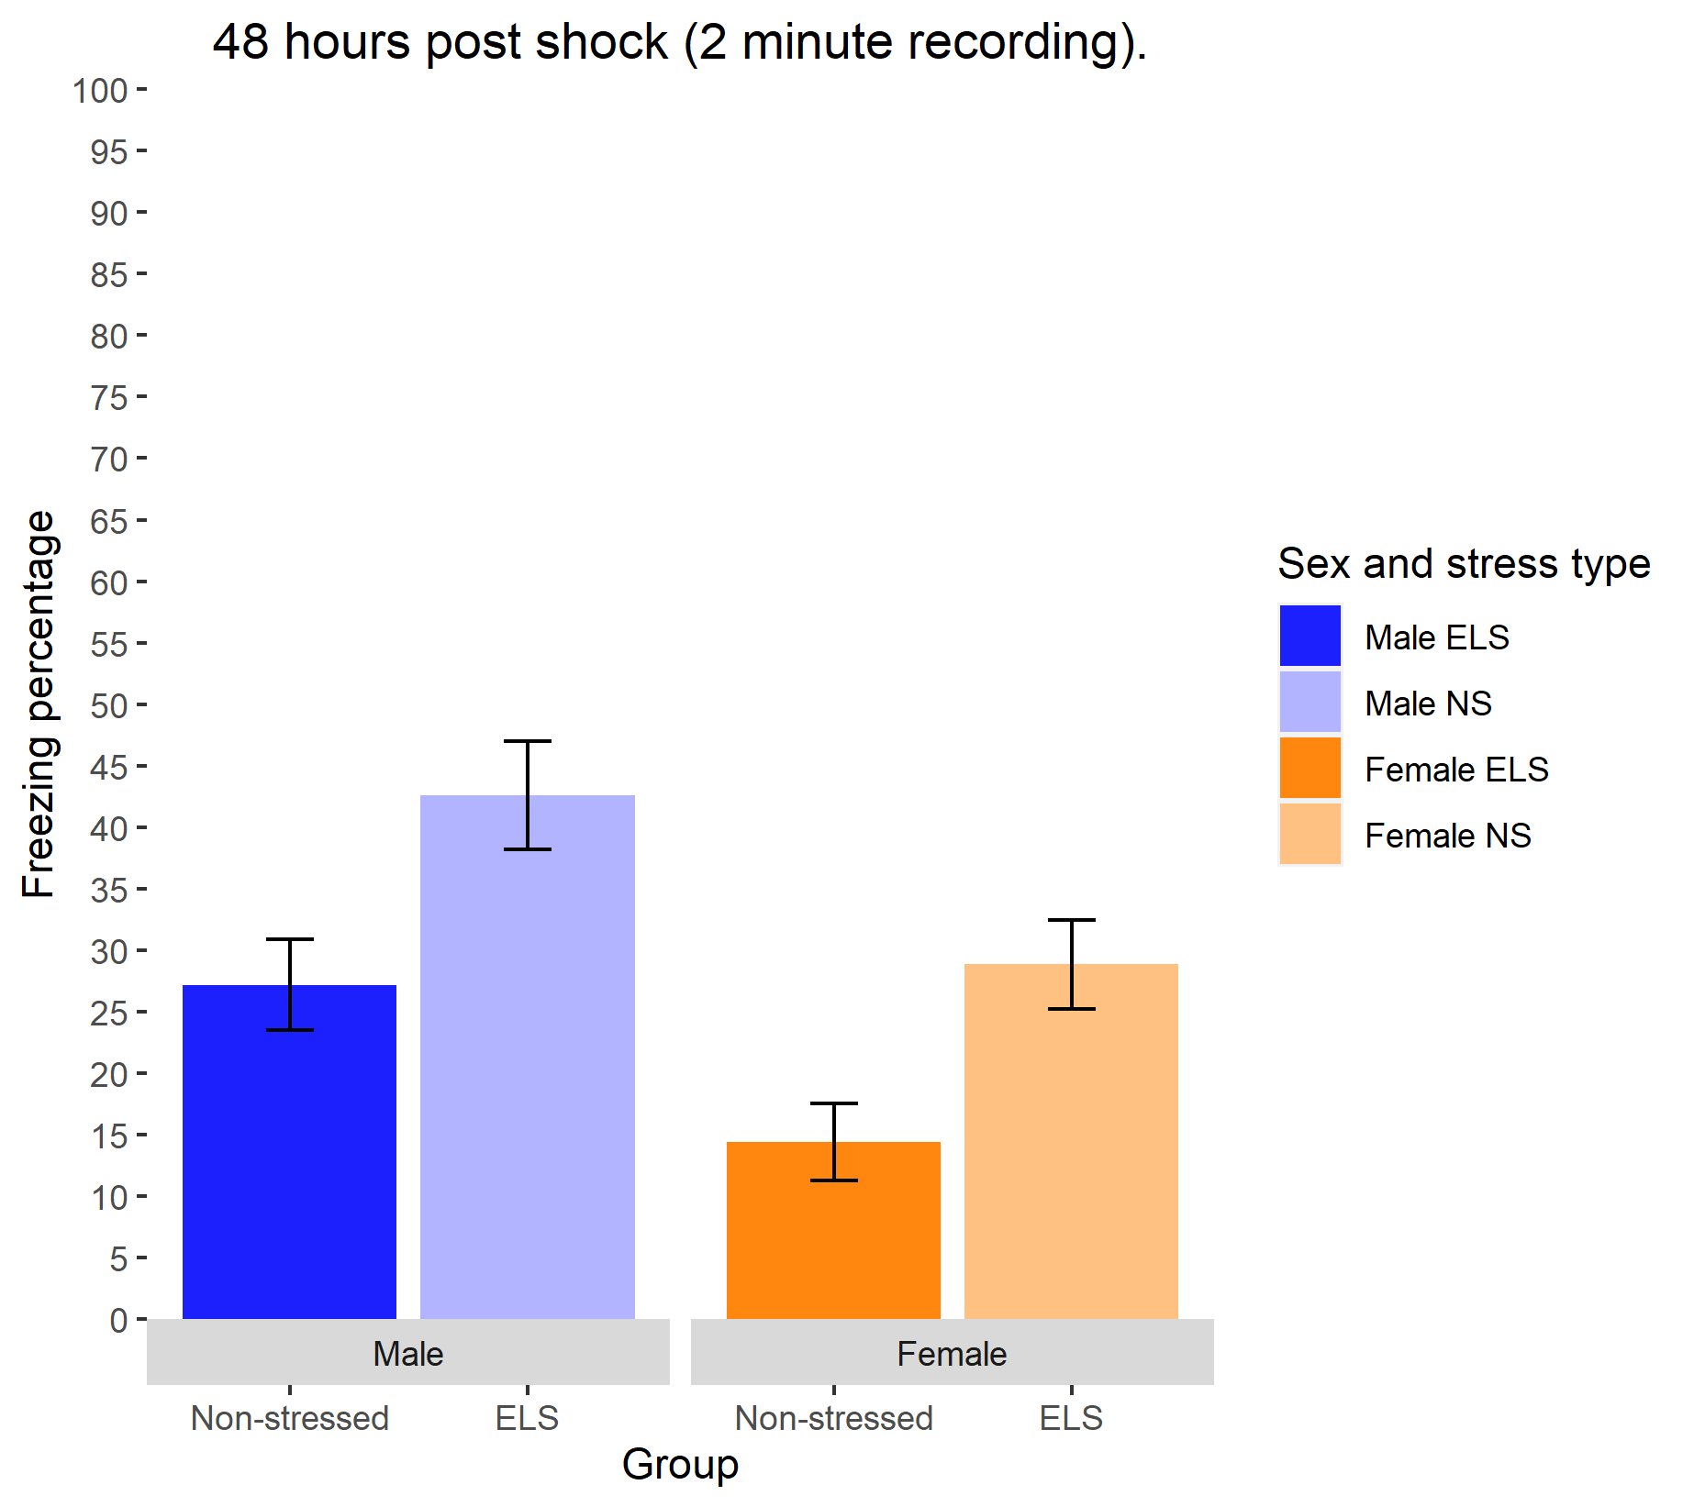

Results here are HIGHLY significant. No interaction but very significant main effects. The error bars are already suggesting this, however this is already showing evidence of a floor effect (compared to the histogram on page 6).

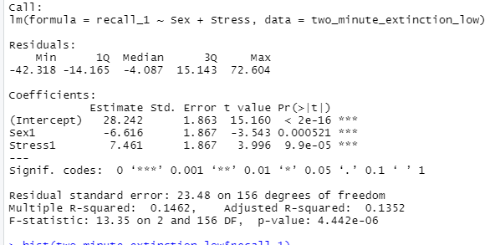

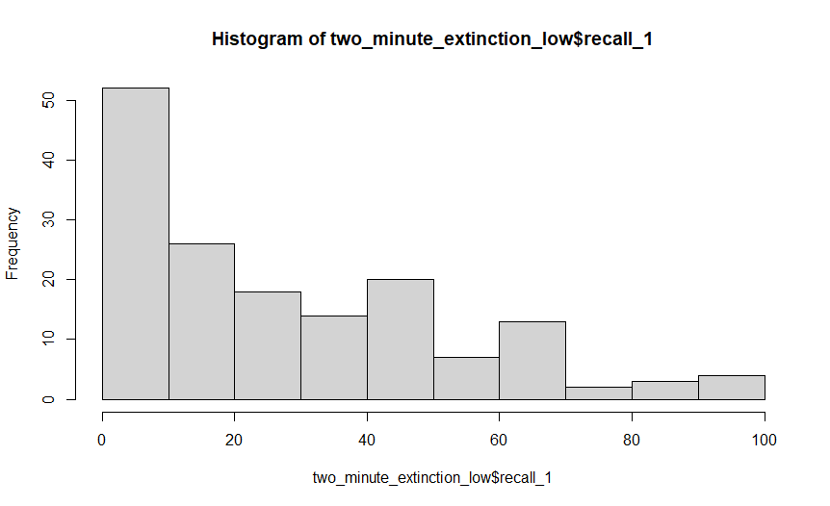

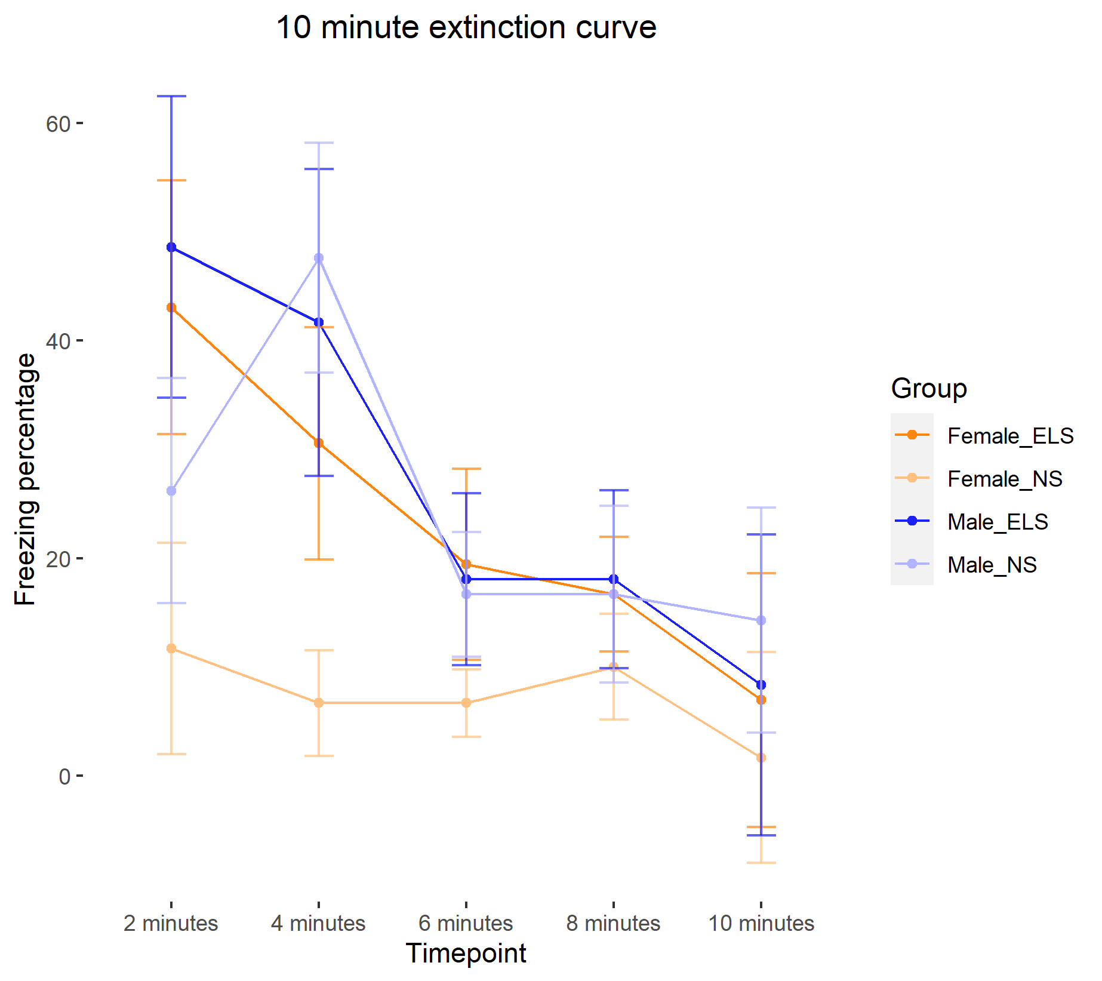

Extinction recall (48 hours following extinction training).

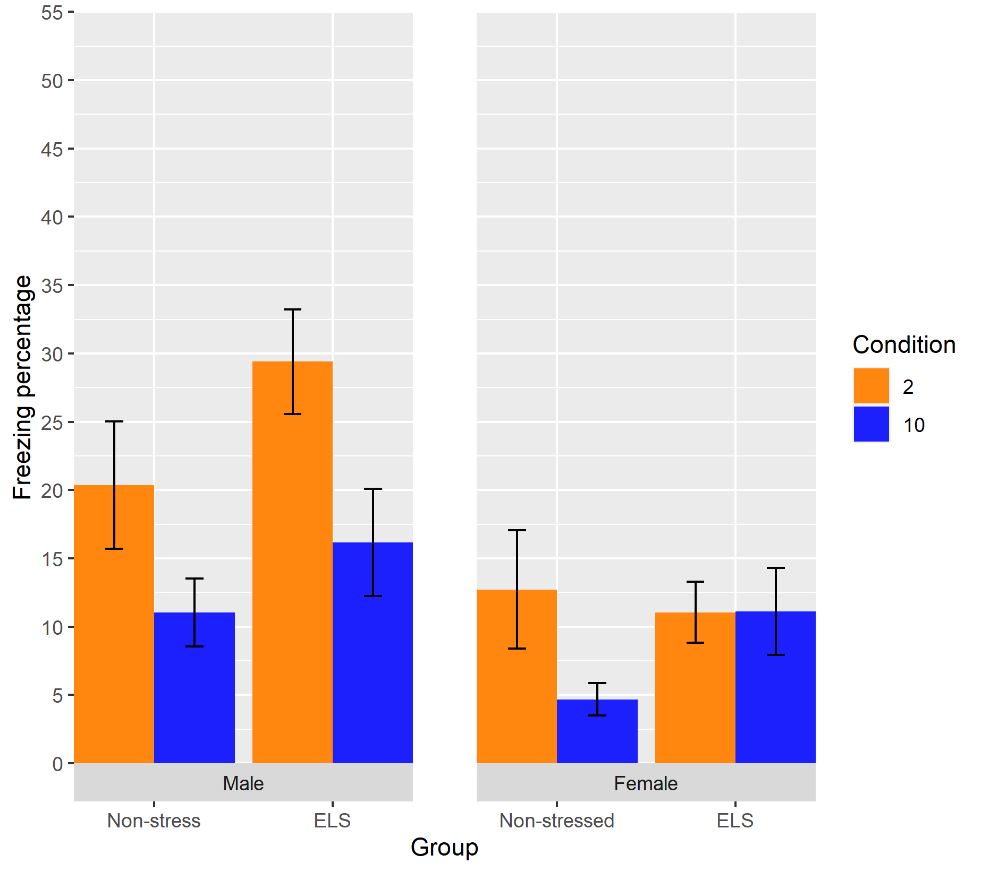

Results here show significant effect for male stressed. The difference is approaching significance for the non stressed males. For females the non stressed and stressed differences are both highly non-significant.

Floor effect here becomes very apparent in the histograms.

Below are the histograms of the DV. Layout is the same as above   
Each column represents 2 or 10 minutes. Row 1 to 4 is   
M ELS   
M NS   
F ELS   
F NS

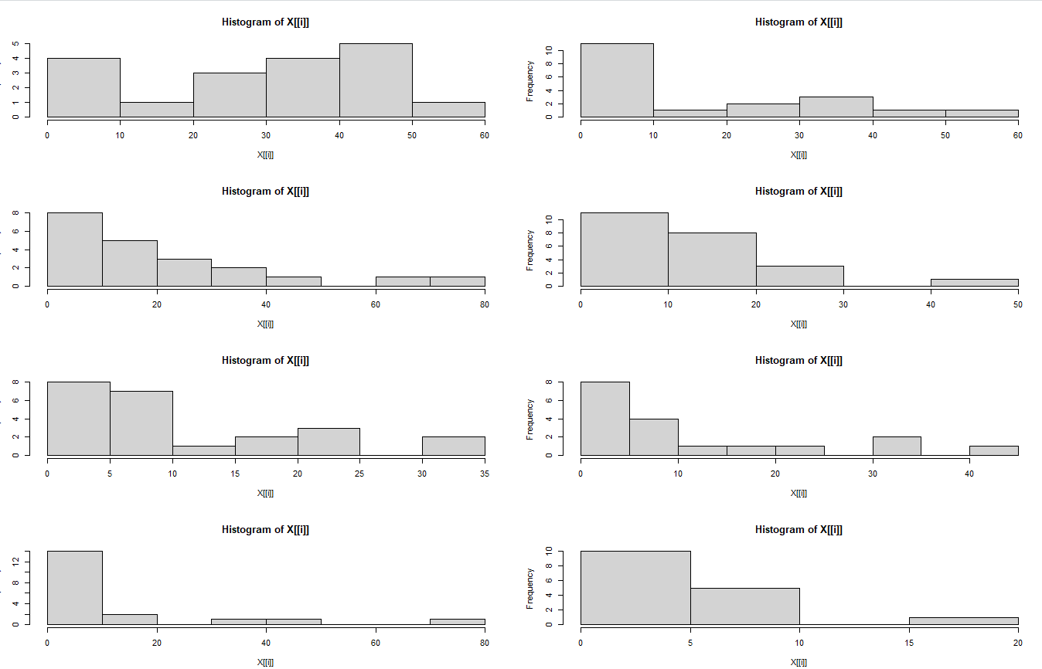

Below results should be interpreted with serious caution. The n’s here are low (5-9) due to COVID (first cohort of low shock animals was cut short and there were no measurements for this). The high shock group has n of (13-21). As above I have not yet conducted the inferential tests on this yet.

Reminder shock

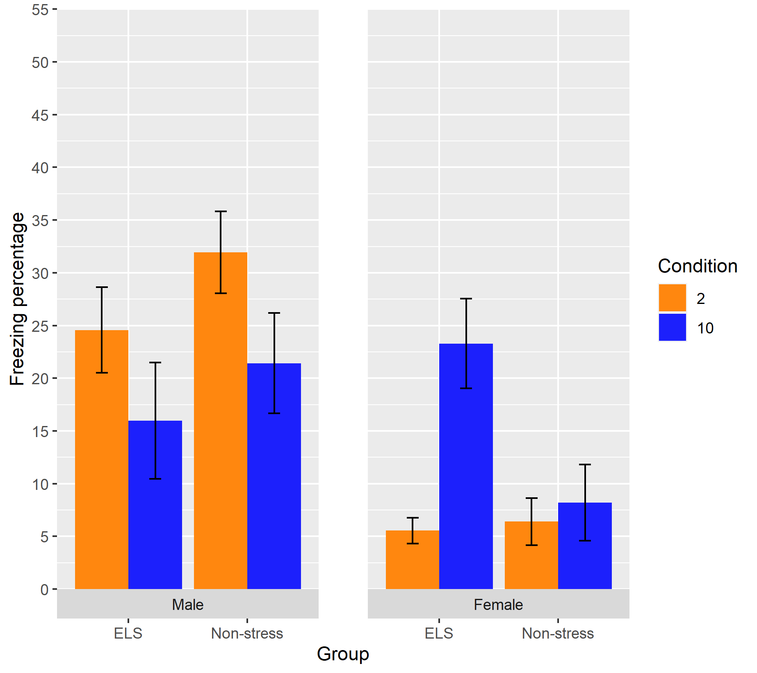

Reminder recall

